|  |  |
| --- | --- |
| **DATE** | 15 November 2022 |
| **TEAM ID** | PNT2022TMID26051 |
| PROJECT NAME | Smart crop protection system for agriculture |

**CREATE IBM WATSON IOT PLATFORM AND DEVICE**

**STEP 1:** Login to IBM cloud account

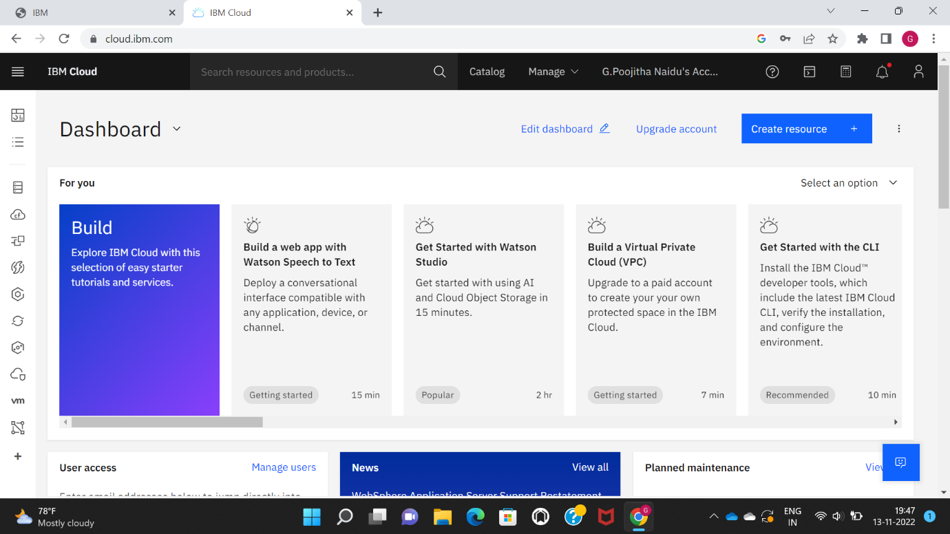

STEP 2: Search for IoT platform and register it with IBM cloud account

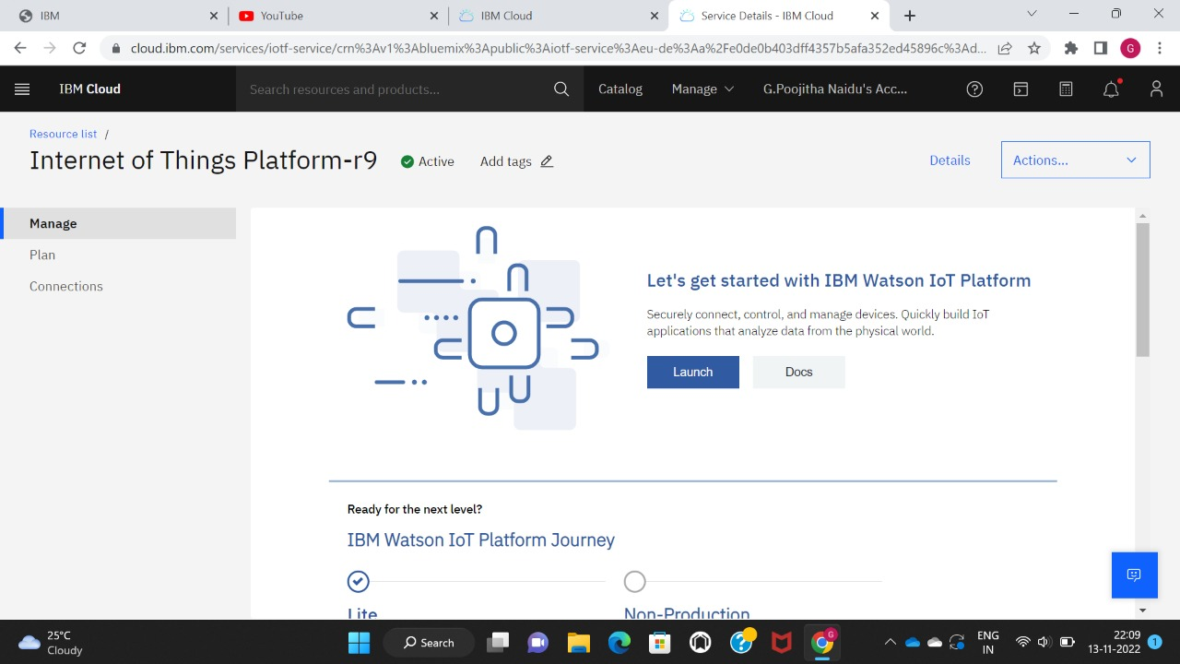

STEP 3: It will be prompted to IBM Watson IoT platform

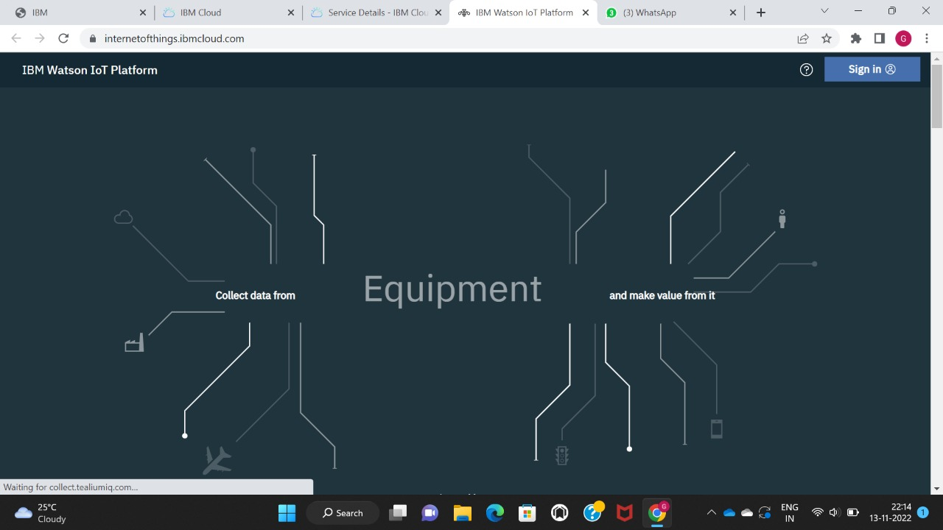

STEP 4: Now create a device and register the device for the simulation

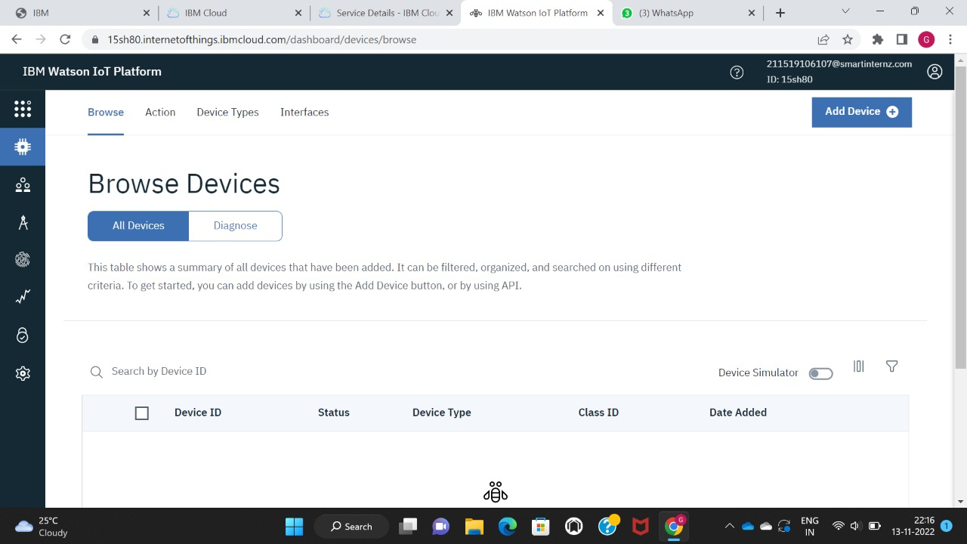

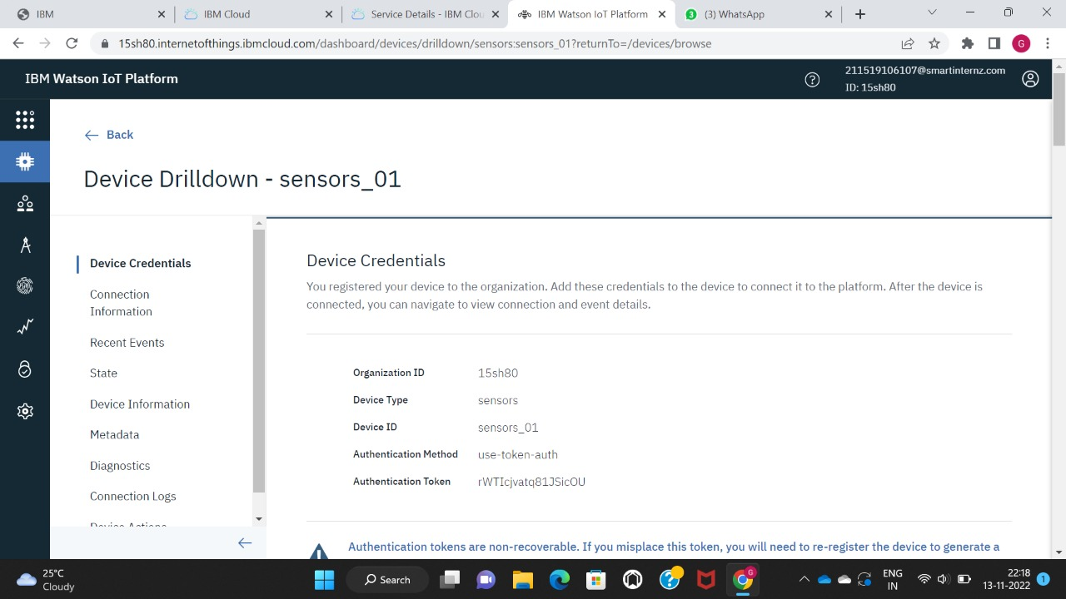

STEP 5: Then enter the commands that need to be generated in the node red.

STEP 6: The input requires the commands and conditions that need to be displayed in the Node-Red

